**Azure**

Lab Guide

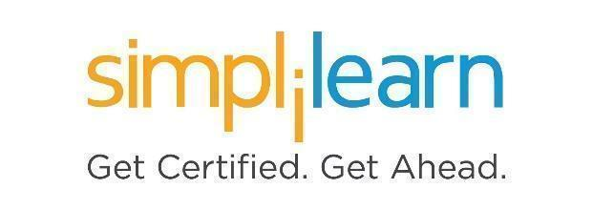

**Note: The screenshots used in Step 1 are only for your reference. Your LMS may look different depending on your course content.**

This section will guide you to:

* Use labs for executing all the demos included in this course

This lab has two subsections, namely:

1. Starting practice labs on LMS
2. There are three ways to search and create the services or resources

**Step 1:** Starting **Practice Labs** on LMS

* Log in the Simplilearn LMS
* Go to the respective course

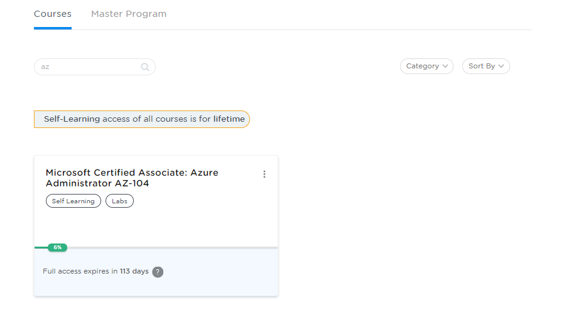

* You will see the course TOC page, click on **PRACTICE LABS**.

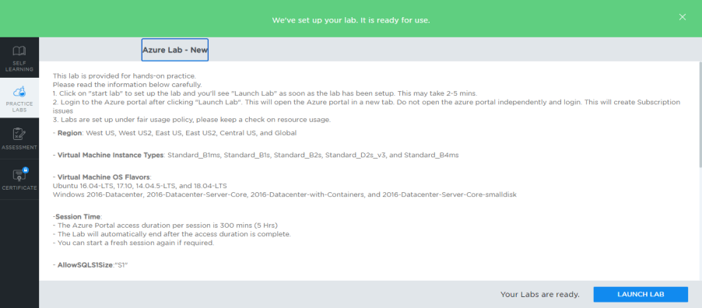

* A new window will open. Read the instructions and click on the **LAUNCH LAB** button**.** This will launch the practice labs for this course.
* In the next window, click on the **Auth URL**, which will direct you to the Azure console in a new browser tab

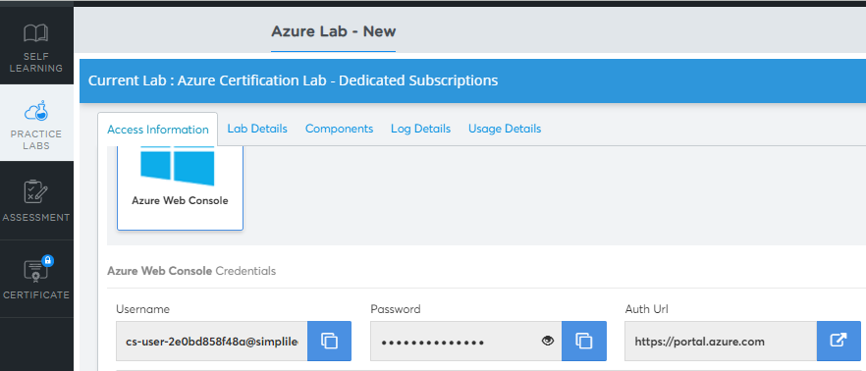

* In the newly opened tab, you need to provide the login credentials to get started.
* You will be able to access the required services and resources in this console.

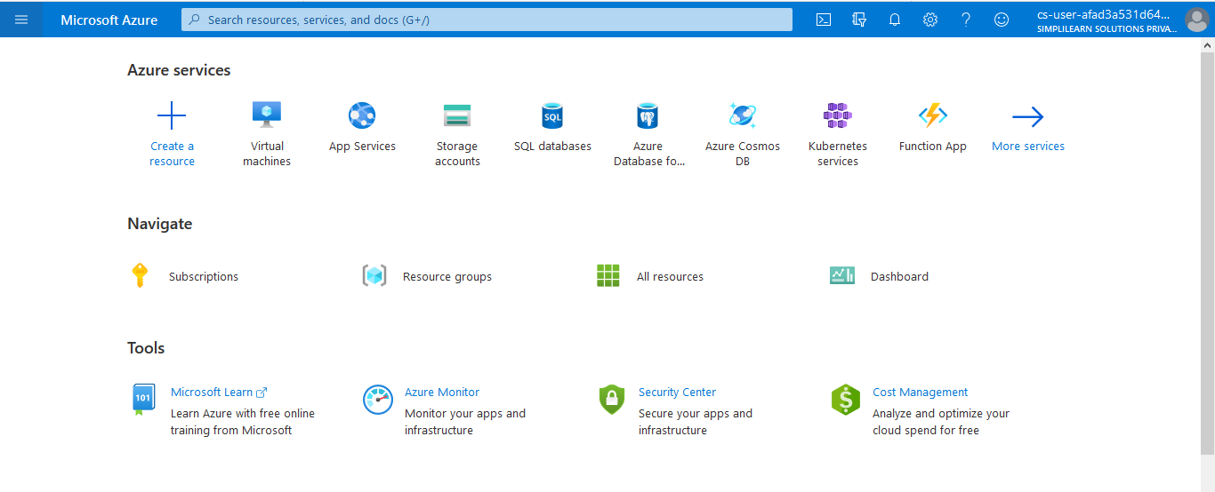

**Step 2:** There are three ways to search and create the services or resources

* You can create services or resources by clicking on the **+** **Create a resource** option.

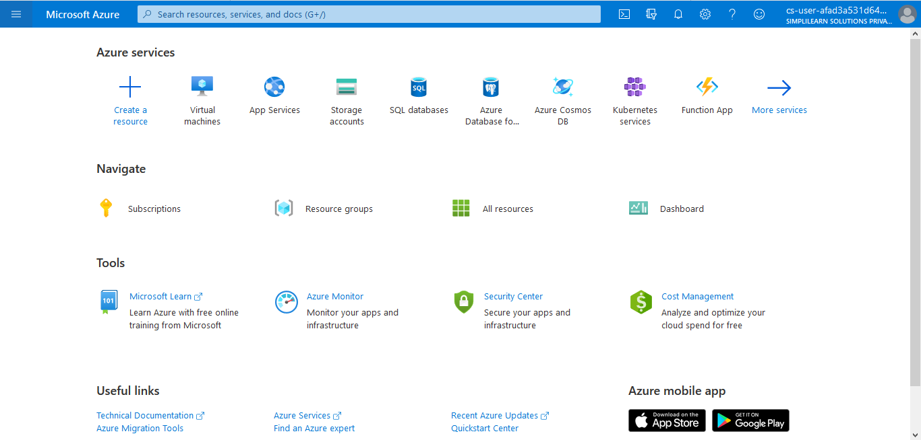

* You can search services or resources by clicking on the search tab.

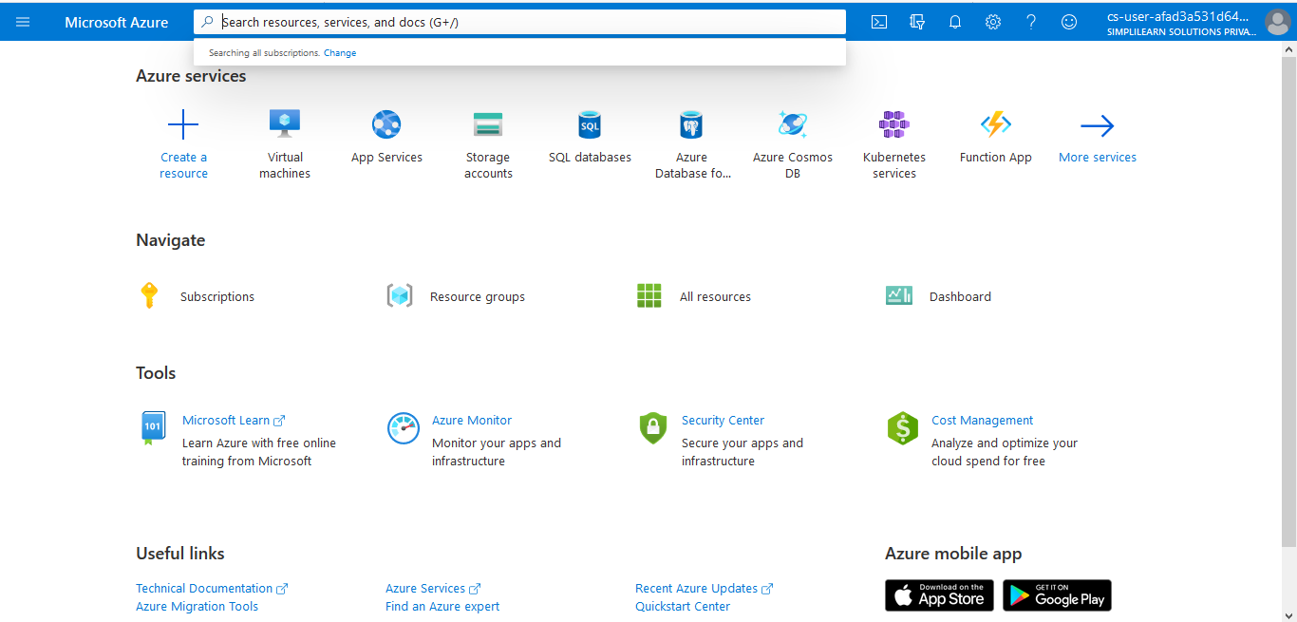

* You can create services or resources by clicking on the **+** **Create a resource** option on the left side pane.

